INFO 6053 Automated Test Tools

Project # 3: Automated Testing Using Selenium WebDriver

**Submitted To: - Submitted By: -**

Professor Susmita Haldar Amanjot Kaur(0914790)

Amandeep Kaur Brar(0949470)

Manpreet Kaur(0962955)

Aman Chhabra(0961874)

**(Group : 12)**

**Introduction of selenium**

Selenium refers to a group of tools which are widely used for cross-browser testing. Selenium is the most preferable toolkit for automation testing of web applications because:

* Supports all browser such as google chrome, internet explorer, safari, opera, Firefox
* Open source
* Easy to use
* Supported by multiple operating system such as Linux, windows, Mac
* Supported by all popular programming languages including java, python, PHP, JavaScript, Ruby etc.

**Selenium web driver:**

Selenium web driver is used to automate testing on web-based applications using cross-browser tests. With the help of selenium web driver, test scripts are designed as per tester required programming language. Selenium web driver proved useful for creating browser-based automation suites and tests, creating of scripts on different environments.

**Selenium WebDriver test of add contact form:** By using the selenium WebDriver, the data will be automated and added a contact form into the database. The data is filled by selecting the tags and values according to their fields. Starting from the first type of relation first name, last name and business name which are or same relation or type. Address1/2/3 are given different fields following city, province, Country and postal code. The further three fields are assigned as E-mail addresses, three drop down options for phone type followed by phone numbers. Last three input fields are for Three different URL;s or websites links in the form. At the bottom we have two buttons for Save address and Clear form, one link to return menu (Cancel).

**ADD A NEW CUSTOMER FORM**

To implement add new contact using selenium web driver, we firstly set the properties for the webdriver to the location of our computer and then created a new instance of the chrome driver using

WebDriver driver = new ChromeDriver();

After that, by using get command we let our cursor visit the required web link i.e. <http://localhost/index.php>. And then, in the code we made our cursor click on “Add new Entry” by the following piece of code: -

Driver.findElement(By.linkText(“Add New Entry”)).click();

Thereafter, to fill form and add new contact automatically, we inspect elements by ID by right clicking on the corresponding fields.

After that, with the help of code, we filled values in the fields such as, to select address type, we used following code: -

WebElement addr_type = driver. findElement(By.id(“addr_type”));

Addr_type.sendkeys(“Family”);

Similarly, all other fields of the form were filled by the same method i.e. findelement by id

Such as :

WebElement addr_region = driver. findElement(By.id(“addr_region”));

Addr_region.sendkeys(“South”);

And,

WebElement addr_phone1 = driver. findElement(By.id(“addr_phone1));

Addr_phone1.sendkeys(“4379843098”);

After filling all the fields of the form by the above way, we applied assertion on our results. For that, we used xpath to retrieve the path of the success message and stored into a string variable named actualResult. After that, we strored expected result of success message in the expectedResult variable and used a Boolean variable to compare the actual and expected results and, if both matched then our assertion turned it out to be true.

After running the program, we can find a message “It Added a new contact” on the console.

**Edit an existing contact**

In this form we are going to edit existed result.

* First, we created new java class named as “EditExistingContact.java”.
* Added libraries and packages which are required.
* In class, firstly I set the property for “webdriver.chrome.driver” to be the location of my computer. To run the webdriver as localhost it is required step.
* Thereafter, created an instance of chrome driver.
* This instance is being used by chrome driver to visit webpage <http://localhost/index.php>.
* Driver find element of list all entries.
* To perform click button we copied the Xpath of click button and pasted inside code.
* Next, we started editing existed form. To do this i found existed webElement “addr_type”.
* Then find other web elements one by one and to edit these used clear method to clear existed data in that web element.
* **Note:** If we will not use clear method before adding new data it will add data with existed one.
* Thereafter, we can add new data by using this line of code “addr_type”. sendKeys(“Home”).
* So, we can edit data one by one for all test boxes in form.
* Then, we can click on save address button to submit the new data.

**Assertion of result**

* When form is submitted successfully, we received text written as” the address book entry was updated successfully”.
* We can copy Xpath of that text to get that actual result to compare with expected result.
* Here we used assert equals to compare those result and if assert is true it will print confirmation in console.

After that data will be updated.

**INPUT ERROR :**

1. Initially, It work same as another test forms : provide path to the chromedriver, create instance of webdriver and through get method access <http://localhost/index,php>
2. In this we are going to check the functionality when all the fields of form are empty, while clicking on submit it give error.
3. By.id or By.link are used to get the information of each and every field through navigation tab on chrome browser.
4. Use id’s name. sendKeys(“”) to send all the fields without any data.
5. Use step 4 in all the other fields s well.
6. Find the name of submit button and perform submit event on it.
7. Put assertion to check its functionality and store the actual result through xpath and getText() and store it into actualresult variable.
8. Perform assertion and compare actual and expected result with assertTrue();
9. Print a message on console “Please Enter atleast one name field” for user.

This Test check in selenium driver through chrome browser whether all the fields are Empty or not and it handle it properly through assertion. If the result is not true, it throws an Exception.

**SCREENSHORTS:**

**ADD FORM**

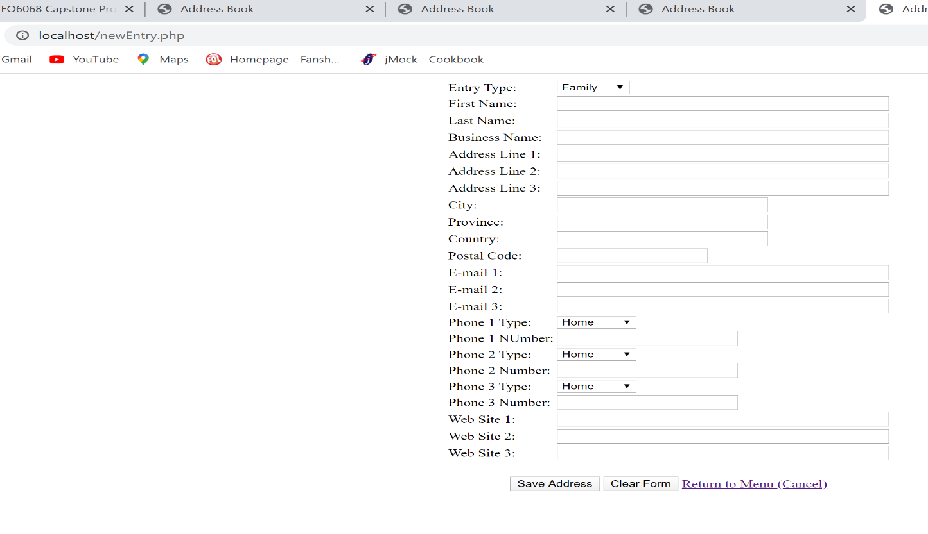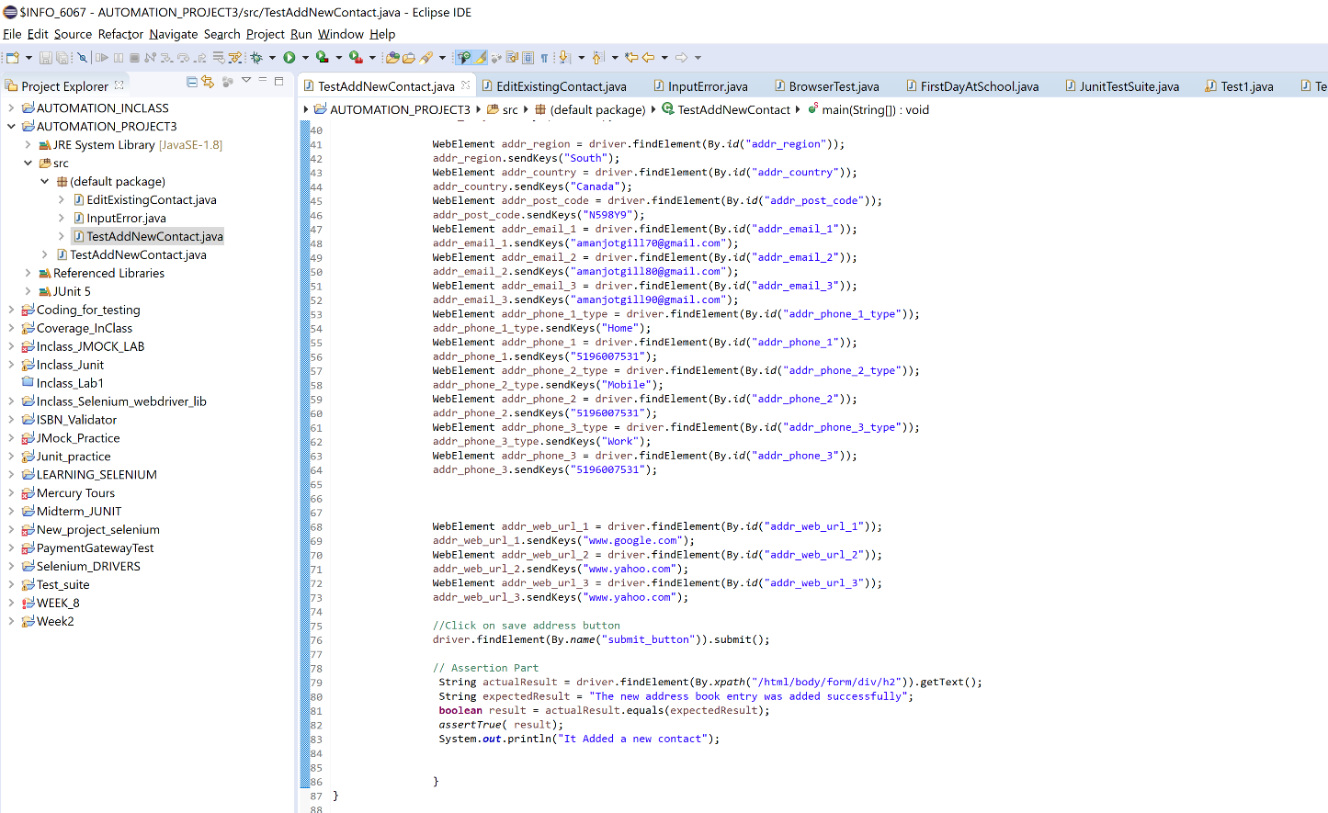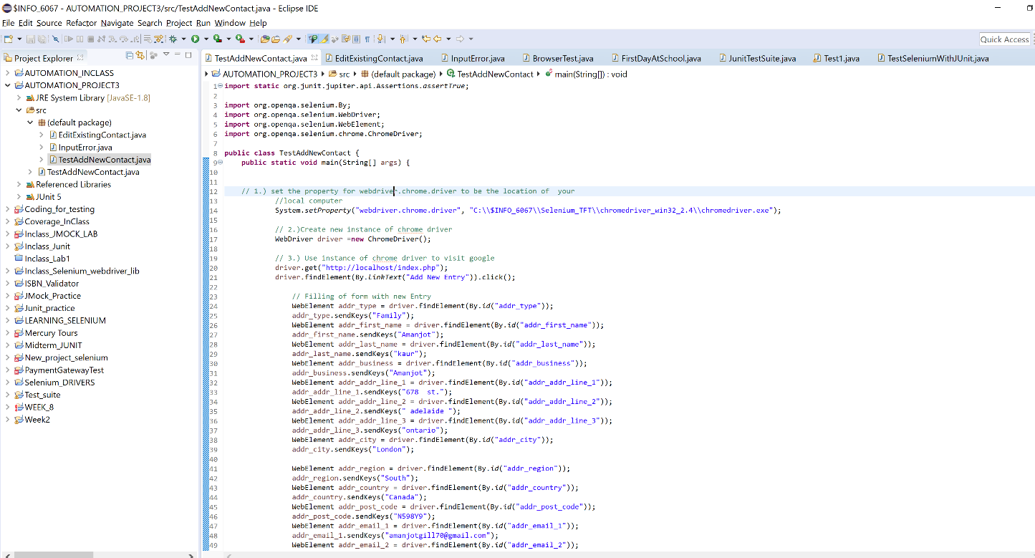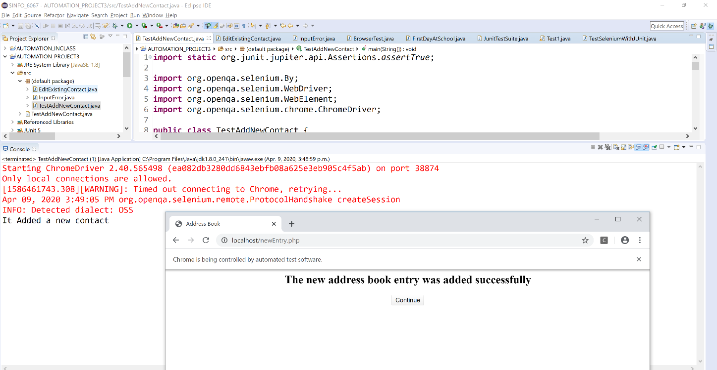

**EDIT FORM**

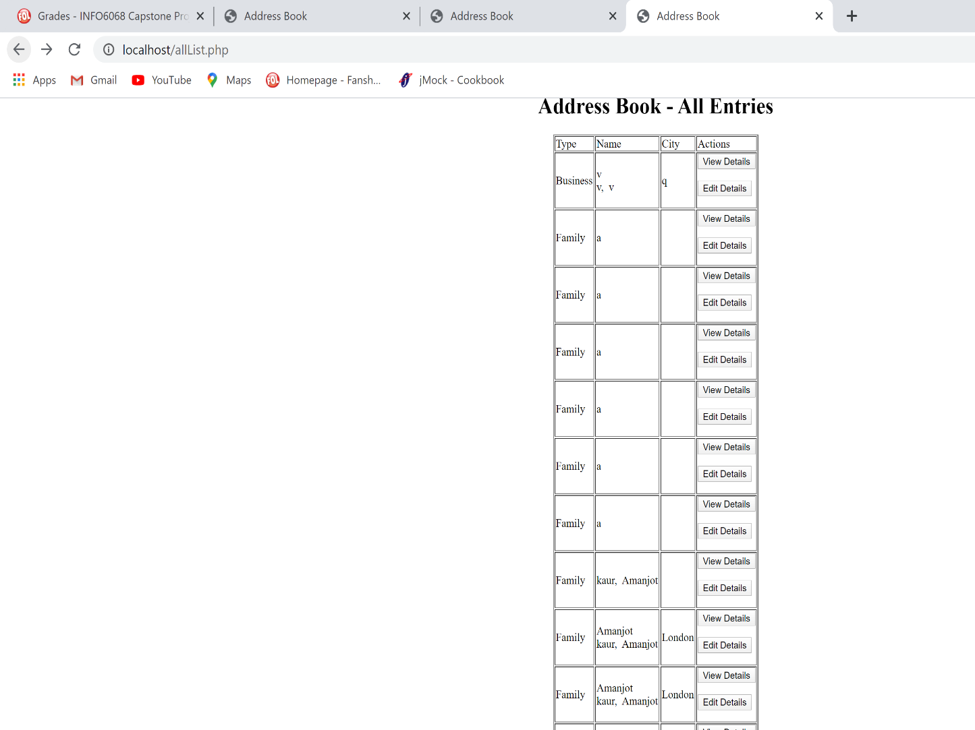

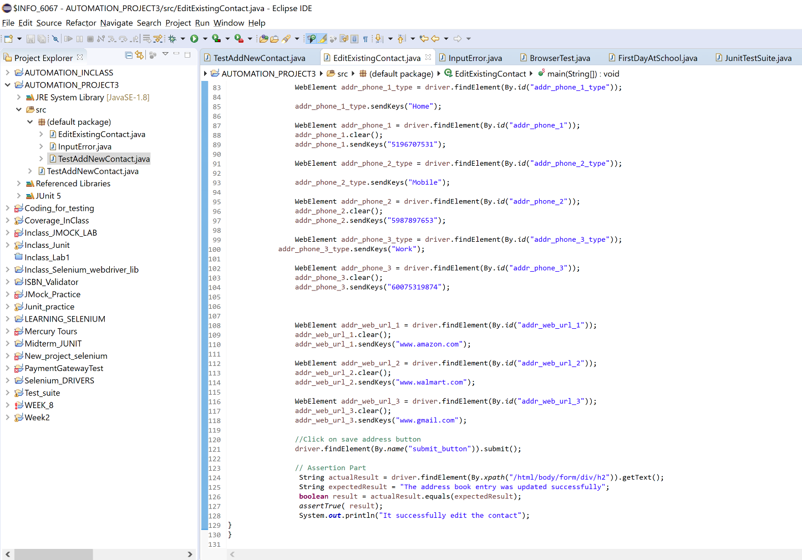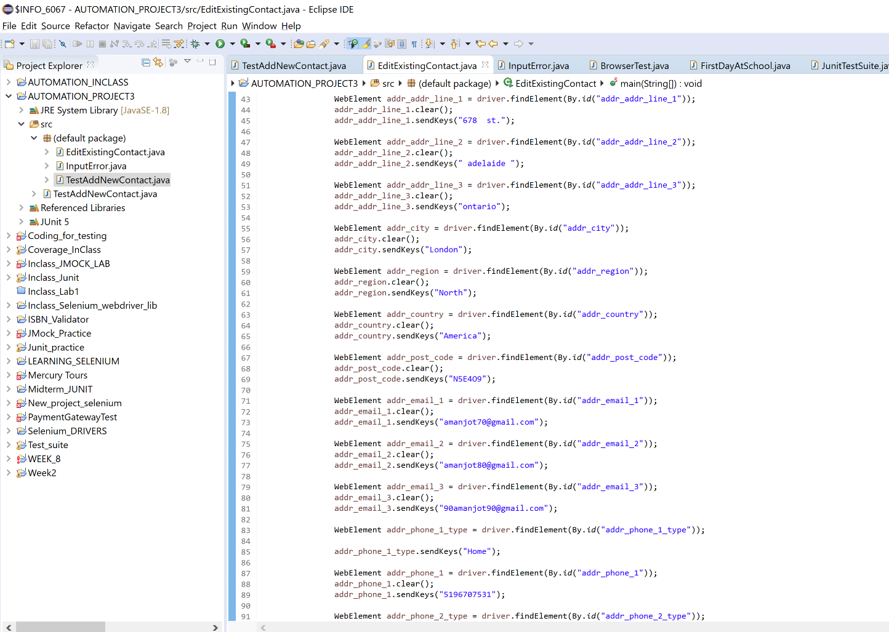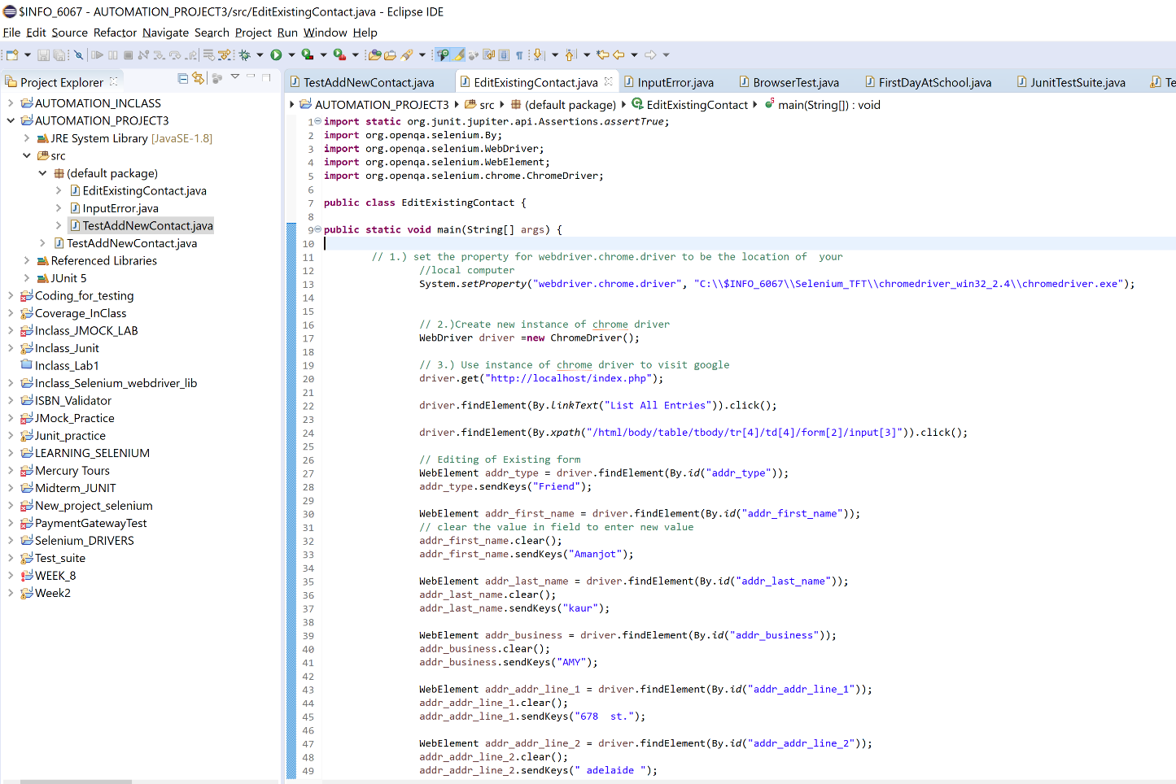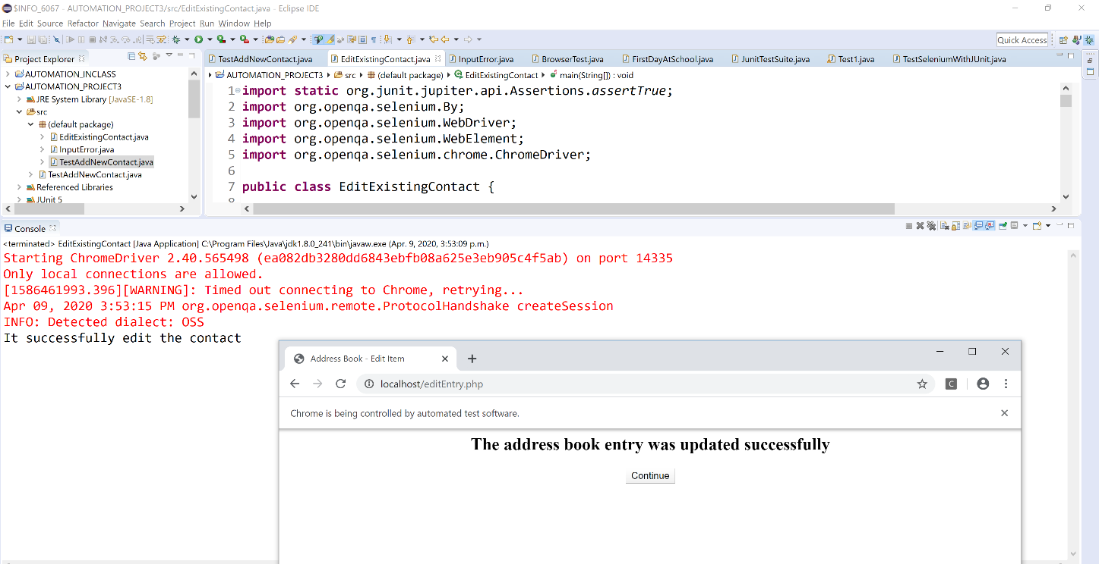

**INPUT ERROR FORM**

